**Mobile Robot Controlled using a Smartphone camera**

By: Mikhaela Rain Francia Roy

Module: PDE3400 Design Engineering Major Project

Supervisors: Dr Tao Geng and Nick Weldin

Table of Contents

1. Introduction 2

2. Literature Review 2

3. Project Development 2

3.1 Software Development 3

3.2 Hardware Development 5

3.3 Combined Development 5

4. Testing and Development 5

5. Conclusion and Future Development 5

References 5

# Introduction

Technology has been exponentially developing until it has become a part of us and our daily lives. It comes in many different shapes and forms, for example, mobile robots, smartphones, computers, and many more. This technology has assisted us more than we could imagine, it can be used in social robotics, education, healthcare, and entertainment or it can be used to complete tasks collaboratively.

As the major world population owns a smartphone and a computer whilst having access to Wi-Fi, there are several ways to take advantage of these devices such as controlling a mobile robot with a smartphone or accessing the camera of the smartphone to control the motors of the mobile robots to track a ball and many more projects that can be completed.

Introducing the *‘Mobile Robot Controlled using a Smartphone camera’*, this report will be exploring related projects, how the project at hand can be improved, and the process it takes for the project to be completed. The purpose is to take advantage of the devices that most of the world’s population has, smartphones which will reduce the cost.

The project aims to design an algorithm to detect a moving object using computer vision with a smartphone whilst detailing the process throughout the report.

The objective of this project is to:

* Detect an object by having a fixed phone on a mobile robot that will allow the computer to stream from a smartphone app.
* The computer and smartphone should be connected to the same network to communicate with one another.
* Ensure that the mobile robot is following the object at a certain distance. When the ball is close to the mobile robot, it should not move until the ball is within the frame.
* Reduce any latency in the video stream while the mobile robot is detecting and tracking the object.

Additionally, there will be a discussion on different types of projects that have been previously completed to compare any similarities within the project at hand to seek any improvements that can be made to the concept of using a smartphone to control a mobile robot.

# Literature Review

[**NEEDS TO BE COMPLETED]**

# Project Development

This project has been divided into two categories; the hardware and the software development, for the purpose of debugging. This section will explore the different methods that was used for testing and validating the advantages and the disadvantages of the methods whilst concluding the appropriate approach needed to complete this project.

## 3.1 Software Development

Beginning the software development, methods were explored to choose an appropriate approach that will allow the mobile robot to track a ball using computer vision to complete this project. The main characteristics needed to identify a ball is

by using contouring to recognize the features such as it being a , centre point and the radius. There are other ways to detect a ball but this is an effective method to gather information to be used to measure the distance between the mobile robot using computer vision and the (x, y) co-ordinates to determine where the ball is in the frame.

The first method of many that have been explored is using the Haar Cascade. It uses positive images (contains the desired object) and negative images (does not contain the desired object) to train a classifier. This approach uses machine learning to detect the objects based on the positive images that have been collected. The advantage of this approach, depending on the trained model, it can be used to accurately distinguish similar featured objects. For example, it will be able to distinguish the parameters that have been trained to the ones that are unknown objects to the classifier. The issue with this method is that it is high-false positive detection which can cause issues with the proposed system (ball tracking). [[OpenCV: Cascade Classifier](https://docs.opencv.org/3.4/db/d28/tutorial_cascade_classifier.html)]

The second approach is to use Hough Circle Transform. The idea of this method is to identify a potential circle through detecting edges then leads to calculating the radius of the potential circle’s parameters.

Figure 1 demonstrates the main algorithm used for tracking the desired object. With the focus of defining the parameters of a ball’s characteristics, such as the colour, contours (circular, radius etc.) and the centre point of the object. As shown, these parameters are to initialise the OpenCV for the computer vision aspect of the project.

* Discuss the different uses of the methods that was tested and validated against many other approaches
* Discuss about the system that needs to be built in order to complete this project
* Discuss the flowchart and how you came into conclusion on the features needed to be extracted in order to detect the desired object

Current system:

* Does not detect multiple objects in frame
* Background interference
* Bluetooth connection established

Improvements:

* Identify only round objects using machine learning
* Use the x co-ordinates to move the motors to the allocated directions.
* Do all calculations in python such as pixel count and the direction control for motors
* Machine learning to train a model
* Uses pixel based to find the distance between the ball and the camera
* Send correct data to move wheels forwards, backwards, left and right

Figure : Ball Tracking Flow Chart

* Add the algorithm of what happens to the x value, for example, x > 350: print left.
* Add the electronics algorithm of what happens when the x value is a certain number

## 3.2 Hardware Development

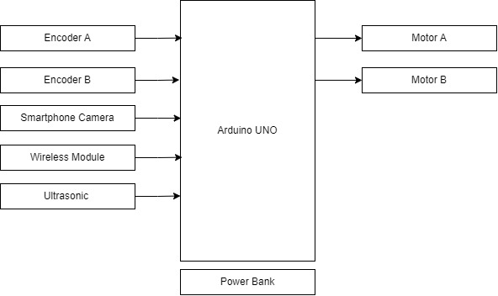

Figure : Electronics Block Diagram

Current system functionality:

* Be able to move forwards, backwards, left and right with manual input
* Bluetooth connection between Arduino and computer
* Able to send data to Arduino from python to turn on LED

Improvements:

* Move according to the data being received from Arduino
* Need to have certain distance from the

## 3.3 Combined Development

[Discuss how the development individually is going and the combining process and the difficulties that were encountered. How was this fixed to ensure that both programs are compatible with one another.]

# Testing and Development

Show testing and development documents.

* Tested multiple methods such as Haar Cascade, Hough Circles Transform and Simple Blob detection.
* Show the different results that have been taken to improve the current system using screenshots
* Explain each process and the steps on how to improve them

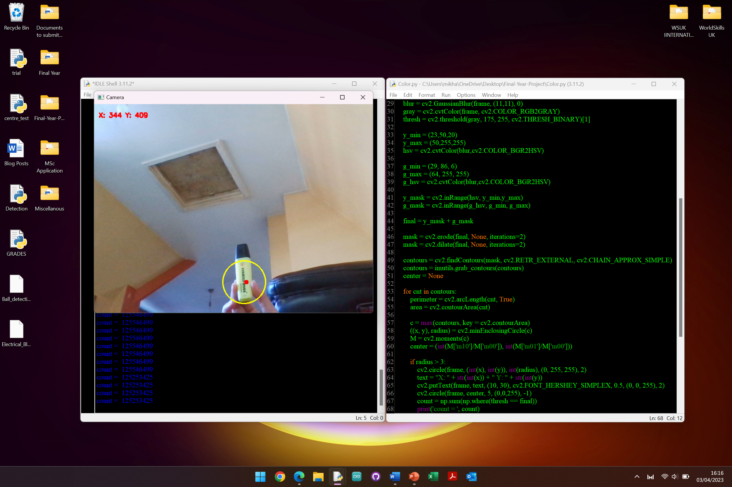

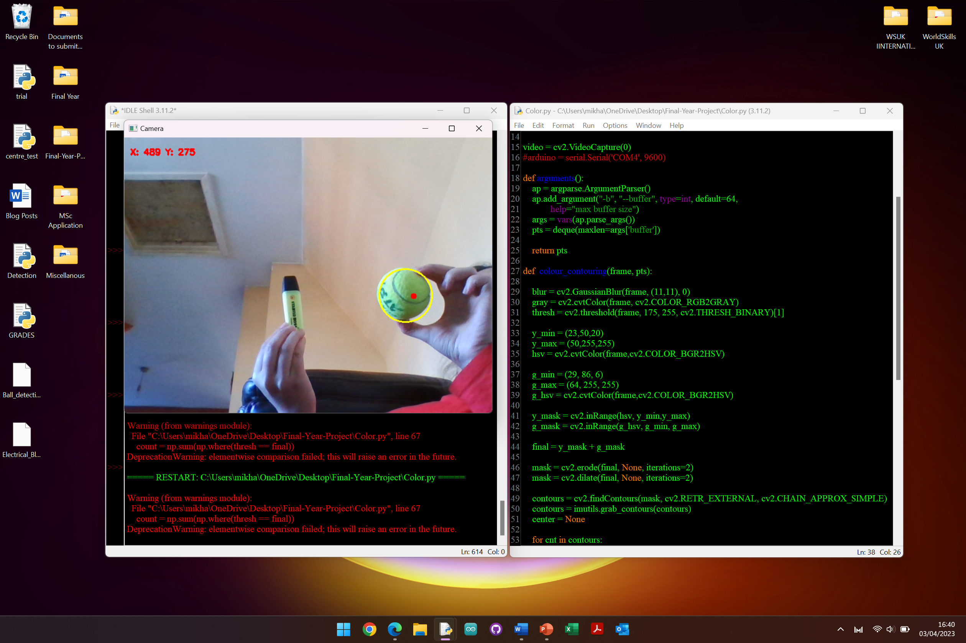

# Conclusion and Future Development

# References

**There are no sources in the current document.**